Hexadecimal-Decimal

Why do we need hexadecimal numbers (Base 16)?
Programmers found binary too tedious and decimal was not practical for computers so they invented hexadecimal

But why 16 digits?
- A byte has 8 bits
- A nibble has 4 bits
- A byte has 2 nibbles
- 4 bits can hold 16 values (0-15) in base 10

Therefore there is a direct correspondence between a nibble and a hexadecimal value

Decimal (Base 10 ) | Hexadecimal ( Base 16)
0 | 0
1 | 1
2 | 2
3 | 3
4 | 4
5 | 5
6 | 6
7 | 7
8 | 8
9 | 9
10 | A
11 | B
12 | C
13 | D
14 | E
15 | F

Converting Hexadecimal to Decimal (Base 16 to Base 10)

e.g.1 Convert the number 1128 Hexadecimal to Decimal.

Similarly as Base 2, each digit in the number has a weight.

16³ | 16² | 16¹ | 16⁰
1 | 1 | 2 | 8

So,
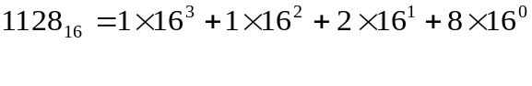
= 4096 + 256 + 32 + 8

= 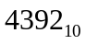

e.g.2 Convert the number FA8 Hexadecimal to Decimal.

16² | 16¹ | 16⁰
F | A | 8

Remember: hex A=decimal 10 and hex F=decimal 15

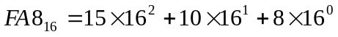

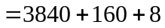

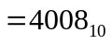

Converting Decimal to Hexadecimal (Base 10 to Base 16)

e.g., Let's express the Decimal number 1341 in Hexadecimal notation.

Quotient Remainder
--------------------------------------------
1341/16 = 83 13
83/16 = 5 3
5/16 = 0 5 (Stop when the quotient is 0)

Again, we need to put the remainder in reverse order which is 5 3 13.
From the conversion table above, Decimal number 13 is Hexadecimal number D. So Decimal number 1341 in Hexadecimal notation (Base 16) is 5 3 D, or

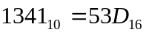

We’ve already known how to convert Decimal number (base 10) to Binary number (base 2), and we can generate the following conversion table for Binary, Decimal and Hexadecimal numbers.

